


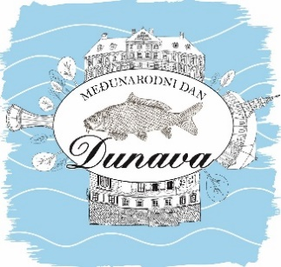




INTERNATIONAL DANUBE DAY – DUNAVFEST VUKOVAR
June 28th, 2025.

APPLICATION FORM - FIŠ PAPRIKAŠ COMPETITION

FIŠIJADA 2025.
TEAM NAME:
TEAM
Team members names: | T -shirt size (circle the size)
1. | S / M / L / XL / XXL
2. | S / M / L / XL / XXL
3. | S / M / L / XL / XXL
4. | S / M / L / XL / XXL
5. | S / M / L / XL / XXL
TEAM HOME TOWN:
TEAM LEADER CONTACT NUMBER AND EMAIL:

Payment:
Competition fee per team: 50,00€.
Payment details:
VUKOVAR TOURIST BORD
Account: HR1025000091102033079, ADDIKO BANK d.d.
Model: 24
Reference number: COMPETITOR’S OIB
Description: TEAM NAME – 100% FIŠ EVENT FEE
By signing, I confirm that I am familiar with the stated competition rules in accordance with the Competition Rules for 100% FIŠ 2025, which are an integral part of this application form, and that I accept the terms and conditions set by the organizer.
The final deadline for REGISTRATION of participation is June 21, 2025.
The completed registration form should be sent to the following e-mail address:
info@turizamvukovar.hr

